
GJVR/MXNG/1001307073/20240070 NORTON ROSE FULBRIGHT
Norton Rose Fulbright LLP Advocaten, Notarissen & Solicitors 2Amsterdam, 15th floor Eduard Van Beinumstraat 34 1077 CZ Amsterdam PO Box 94142, 1090 GC Amsterdam The Netherlands
ISSUED FOR TRUE COPY in accordance with section 49 paragraph 3 of the Dutch Civil Law Notaries Act (Wet op het Notarisambt) of a document that was used in a closing at our office on 6 January 2025, by me, Geert-Jan van Rijthoven, civil law notary in Amsterdam, the Netherlands. This statement explicitly contains no judgement as to the contents of this document.

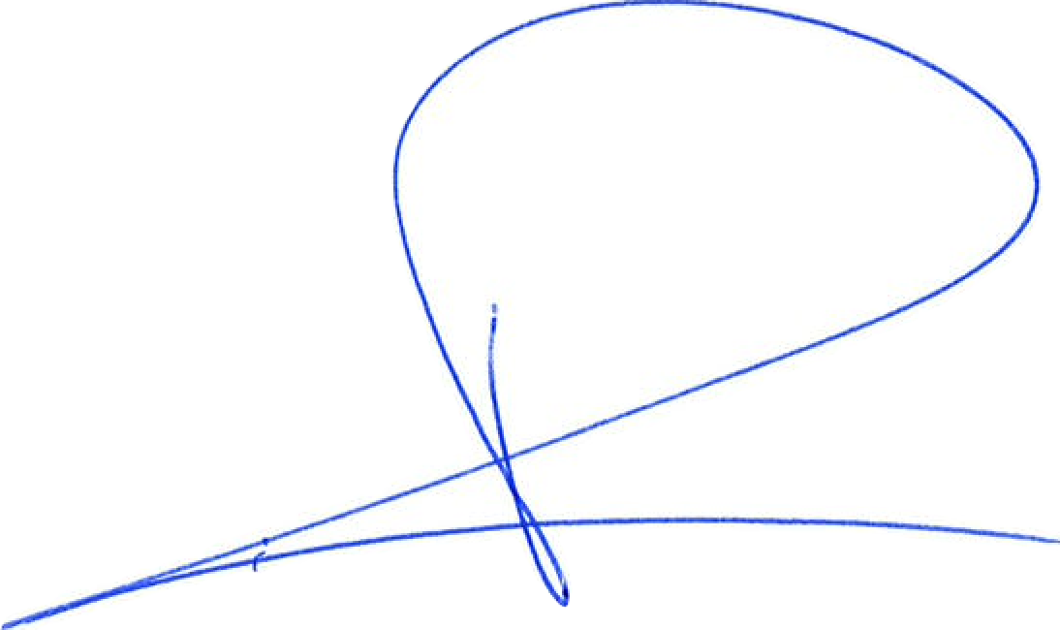
Amsterdam, the Netherlands, 7 May 2026.
1

APOSTILLE
(Convention de La Haye du 5 octobre 1961)
1. Country: THE NETHERLANDS
This public document
2. has been signed by mr. G.J. van Rijthoven
3. acting in the capacity of notary at Amsterdam
4. bears the seal/stamp of aforesaid notary
Certified
5. in Amsterdam 6. on 08-05-2026
7. by the registrar of the district court of Amsterdam
8. no. 11501
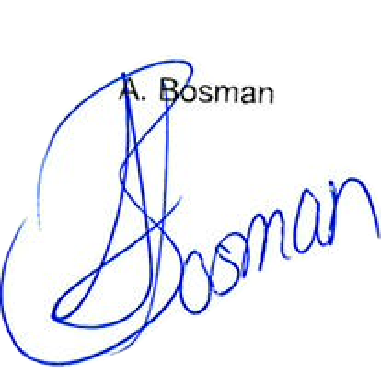

9. Seal/stamp: 10. Signature:

